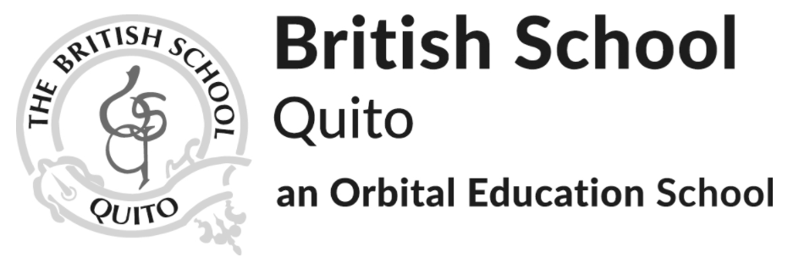

2023-2025 IGCSE Options Guide

‘The capacity to learn is a gift; The ability to learn is a skill; The willingness to learn is a choice’

Brian Herbert

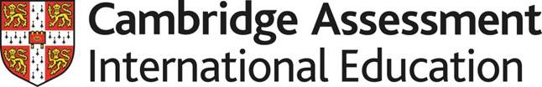

Cambridge IGCSE is our students first opportunity to prepare for and sit an internationally recognised qualification in the format of an externally assessed exam. The syllabuses are not only designed to increase students understanding in a particular subject but also develop essential lifelong skills, including creative thinking and problem-solving.

At BSQ we believe that it is important that students are given as many opportunities as possible to sit this style of formal recognised qualification as possible before they enter IB level study which is one of the reasons why we introduced the Cambridge IGCSEs to our school. This rigorous qualification not only gives parents, teachers and students an externally validated reference point but is a valuable addition to university applications.

Course of Study

Students taking the IGCSE course of study will take between 7 and 9 subjects according to their choices. Alongside IGCSE courses of study all students will also have lessons in Sociales and Physical Education. In some blocks students have a choice of subject which they should discuss with their teachers to decide whether the courses chosen are appropriate to the individual.

Some subjects have Core (Grades C-G) and Extended options (Grades A*-G) which can be discussed with subject teachers at a later date. Below you will see the 6 blocks available. Everything in blocks 1-4 is compulsory for our students, whereas they only need to take one option from blocks 5 and 6 respectively. A detailed guide on each of these can be found on the next pages.

1 | 2 | 3 | 4 | 5 | 6
English Language and Literature (2 separate IGCSEs)  English as an Additional Language | Literature in Spanish  Spanish as an Additional Language | Maths | Science - Students will study Biology, Chemistry and Physics | History  OR  Geography | Art  OR  Music  OR  Physical Education

Subjects in italics are not choices but are available based on the individual needs of students.

English (First Language) and Literature in English

English is the exploration of how language works. In English (First Language), students study how writers of nonfiction texts use language to create meanings, and they also apply this understanding to create their own written texts. In English Literature, students explore and analyse how writers of literary texts, such as poems, short stories and novels, use language to create meanings within particular contexts.

Assessment Structure

In both English subjects (First Language, and Literature) there is a mixture of summative exams (taken at the end of Year 11) and internally assessed coursework.

Underneath you will see details of each component, including the weightings and the times.

English (First Language)

Component | Paper 1  Reading | Component 3  Coursework
Time | 2 hours | N/A
Weighting | 50% | 50%

Literature in English

Component | Paper 1  Poetry and Prose | Paper 2  Drama
Time | 1 hr 30 mins | 1 hr 30 mins
Weighting | 50% | 50%

Español

El uso adecuado de la lengua servirá en el futuro para un sujeto que la utilice como un medio de participación democrática para rescatar, valorar y respetar la diversidad intercultural y plurinacional. Saber comunicarse desde la producción y comprensión de textos de todo tipo y en toda situación comunicativa, es importante para usar y valorar el lenguaje como una herramienta de intercambio social y de expresión personal.
El aprendizaje de la literatura permite disfrutar, desde la función estética del lenguaje, diferentes textos literarios y expresar sus emociones mediante el uso adecuado de los distintos recursos literarios.
Por otra parte, permite que el alumno acceda a una fuente de disfrute y de vivencias a través de las lecturas. El programa de Lengua y Literatura en español para el año 10 es un curso del IBCSI y pre- BI y se enfoca en el desarrollo de las destrezas que necesitará el estudiante para el programa del Bachillerato Internacional.

Assessment Structure

Las evaluaciones en Español, Literatura del curso del IGCSE se evaluará en los exámenes sumativos. A continuación se podrá ver los detalles de las evaluaciones que se debe realizar al finalizar el programa, en año 11

Componente | Paper 1  Set Text - Open Book | Paper 3  Alternative to Coursework
Tiempo | 2 hrs 15 mins | 1 hr 20 mins
Weighting | 75% | 25%

Mathematics

Mathematics can be seen as a well-defined body of knowledge, as an abstract system of ideas, or as a useful tool. For many people it is probably a combination of these, but there is no doubt that mathematical knowledge provides an important key to understanding the world in which we live. Mathematics can enter our lives in a number of ways: we buy produce in the market, consult a timetable, read a newspaper, time a process or estimate a length. Mathematics, for most of us, also extends into our chosen profession: visual artists need to learn about perspective; economists need to recognize trends in financial dealings; and scientists view mathematics as a language that is central to our understanding of natural events. The study of mathematics will help you to develop transferable skills such as logical thinking, problem solving and communication.

Assessment Structure

Your ability in mathematics will be assessed in summative external exams at the end of the course. Scientific calculators are required in both papers (graphical calculators are not permitted).

Component | Paper 1 or 2* | Paper 3 or 4*
Time | Paper 1 - 1 hr  Paper 2 - 1 hr 30 mins | Paper 1 - 2 hrs  Paper 2 - 2 hrs 30 mins
Weighting | 35% | 65%

*Where there are 2 options this is because there are core and extended versions of the paper, odd numbers are core and even numbers are extended

Separate Sciences (Students will achieve 3 separate IGCSEs)

Students on this route will still be expected to study all three sciences, the subject content and syllabi are included below.

Biology
Biology is the study of all things living. We will look at the microscopic and the macroscopic, at the interactions between organisms and how processes within an organism function. The study of Biology will help you to develop transferable skills such as attention to detail, collaboration, deductive reasoning, data analysis, communication and presenting information.

Chemistry
Chemistry is the study of all things atomic, we look at the smaller than microscopic reasons why the processes all around us work the way that they do. The study of Chemistry will help you to develop transferable skills such as innovation, problem solving and analysis.

Physics
Physics is concerned with the nature and properties of matter and energy. In physics you will explore fundamental questions and try to answer them by observing and experimenting.

Assessment Structure

Your ability in Biology, Chemistry and Physics IGCSE will be assessed in summative exams.

Underneath you will see details of each paper including the weightings and time.

Component | *1 or 2  Multiple Choice | *3 or 4  Extended Answer | 6  Alternative To Practical
Time | 45 mins | 1hr 15mins | 1 hr
Weighting | 30% | 50% | 20%

*Where there are paper numbers this is because there are core and extended versions of the paper, the time and weighting however remains the same regardless of tier

History

History is the study of the world around us and how it developed. We look at the key events of the 20th century that created the modern world. The study of History will help you to develop transferable skills such as analysis, research, critical thinking and empathy.

Assessment Structure

Your ability in History IGCSE will be assessed on a combination of externally marked exams and internally assessed coursework.

Underneath you will see details of each of the components including the weightings and time.

Component | Paper 1  Depth Study | Paper 2  Core Content | 3  Coursework
Time | 2 hrs | 2 hrs | N/A
Weighting | 40% | 33% | 27%

Geography

Through the Cambridge IGCSE Geography syllabus, learners will develop a 'sense of place' by looking at the world around them on a local, regional and global scale. Learners will examine a range of natural and man-made environments, and study some of the processes which affected their development. They will also look at the ways in which people interact with their environment, and the opportunities and challenges an environment can present, thereby gaining a deeper insight into the different communities and cultures that exist around the world.

Assessment Structure

Your ability in Geography IGCSE will be assessed in summative exams and coursework. Underneath you will see details of each paper including the weightings and time.

Component | Paper 1  Geographical Themes | Paper 2  Geographical Skills | Component 3  Coursework
Time | 1hr 45mins | 1hr 30mins | N/A
Weighting | 45% | 27.5% | 27.5%

Art

IGCSE Art & Design syllabus aims to encourage a personal response by stimulating imagination, sensitivity, conceptual thinking, powers of observation and analytical ability. Learners gain confidence and enthusiasm as they develop technical skills in two and three dimensional form and composition, and are able to identify and solve problems in visual and tactile forms. They also learn how to develop ideas from initial attempts to final solutions. An ideal foundation for further study, Cambridge IGCSE Art & Design also develops a greater awareness of the role played by the visual arts in society and in history, broadening cultural horizons and individual experience.

Assessment Structure

Component 1 Coursework 50% Candidates produce a portfolio of up to four sheets (eight sides, maximum size A2) and a final outcome Internally assessed by teachers and externally moderated.

Component 2 Externally Set Assignment 50% Candidates research, develop and realise a project from one area of study from a choice of topics set in an exam paper. Students produce up to 4 preparatory sides of A2 and a final piece. This piece is externally assessed.

Component | Component 1  Coursework | Component 2  Externally Set Assignment
Time | Unlimited prep and final piece creation | 8 hours to create final piece in exam conditions, approximately 3 months preparation period
Weighting | 50% | 50%

Physical Education

Students will study both the practical and theoretical aspects of Physical Education. This course is also designed to foster enjoyment in physical activity. The knowledge gained should enable students to develop an understanding of effective and safe physical performance.

Assessment Structure

All students take two compulsory components.
- Theory Paper (Externally Assessed)
- Coursework (Internally assessed / externally moderated)

Below you will see details of each component including the weightings and time.

Component | Paper 1  Theory | Component 2  Coursework
Time | 1hr 45mins | N/A
Weighting | 50% | 50%

Music

The Music IGCSE allows students to develop their performance and compositional skills as well as their ability to analyse pieces of music. Students will study a variety of musical elements (detailed below) as well as looking into the main historical periods and styles of western and world music. The study of music allows students to develop their creativity, analytical skills and an affinity for music has been shown to correlate with the development of skills in Maths.

Assessment Structure

All students take three compulsory components.
- Component 1 Listening (Externally Assessed)
- Component 2 Performing (coursework, internally marked, externally moderated)
- Component 3 Composing (internally marked, externally moderated)

Below you will see details of each component including the weightings and time.

Component | Paper 1  Listening | Component 2 Performing | Component 3  Composing
Time | 1 hr 15 mins | n/a | n/a
Weighting | 40% | 30% | 30%

