IGCSE General Study Guide 2023:

The Final Two Months

“I didn’t get there by wishing for it or hoping for it, but by working for it.”
Estée Lauder

Contents
General study advice…3-4
English………………………5-7
Español…………………….8-9
Geography……………….10-11
History……………………..12
Biology……………………..13
Chemistry…………………14-15
Physics……………………..16
Maths……………………….17-25
Art…………………………….26-27
Music………………………..28-31
PE……………………………..32-33

READ THIS
The difference between doing OK, and doing really, really well, is how hard you work. Hard work over a few months will make the difference between an A* or a B, or between passing and failing the IGCSEs.
There is no shortcut. You will not achieve freak success through luck. The only way to do well is to work hard over a significant period of time.

Planning for Study
Let’s assume that from Monday 6th March onwards, you work for 2 hours per evening after school. Let’s further assume you work for 4 hours on a weekend. During your week off at the beginning of April, you work 5 hours per day Monday to Friday. That’s a total of 127 hours of independent study.
You study 8 subjects. No one subject is more important than the next and so, we split the time evenly, 15 hours per subject.

How Learning Works
Exam success depends on two key things: the ability to recall and synthesise information, and the skills to communicate your understanding and analysis successfully.
This relies on learning, remembering, practicing and repeating: you need to learn everything there is to know, you need to be able to remember it, and you need to be able to put it together in new and difficult ways in an exam.
Learning:
- You do this by actively engaging with subject material. This means using a variety of methods such as knowledge organisers, past papers, listening to podcasts, reading articles etc. to help you build new knowledge as well as to enhance and consolidate what you already know.
Deliberate Practice:
- You do this by breaking down and practicing the basic skills. This means solving equations, analysing sources, and doing topic quizzes again, and again, and again.
Synthesis:
- You then need to practice slowly, carefully and deliberately answering the questions in IB past papers and similar, which will demand that you put together your knowledge in new and more challenging ways.
And then, you need to do it again. The most effective tool in building knowledge you can use is forgetting and re-learning.

How to Approach Past Paper Practice - 8 Step Method
Practicing past exam papers helps to fine-tune key exam techniques and to refresh understanding of key phrases or terminology. It also helps in terms of time management so that vital time is not wasted on short answer questions which allocate only a few marks. To get the most you can out of a past paper, follow the steps below:
BRAIN (Black Pen):
- Timed, exam conditions (e.g. 1 mark per minute)
- No time restraints, exam conditions.
BOOK (Blue Pen):
- Use your notes
- Use Text Books
- Use the internet
BUDDY (Green Pen):
- Ask your peers
BOSS (Red Pen):
- Use the Mark Scheme
- Ask your teacher

15 hours of English

English Language – 7.5 hours

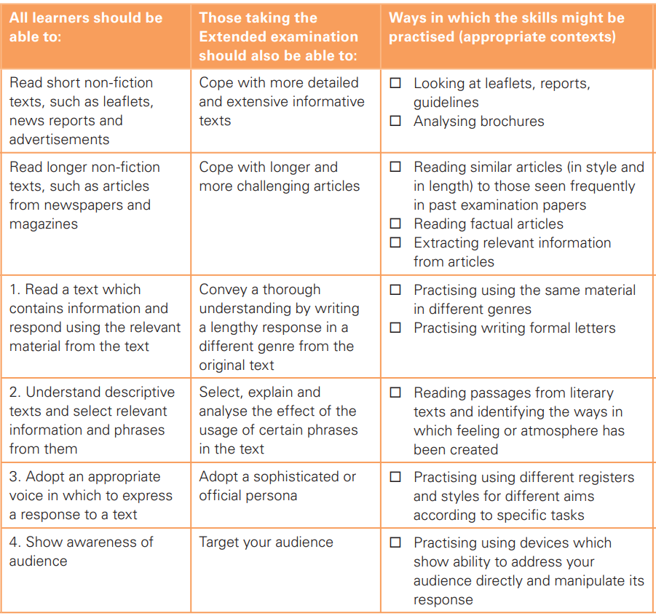
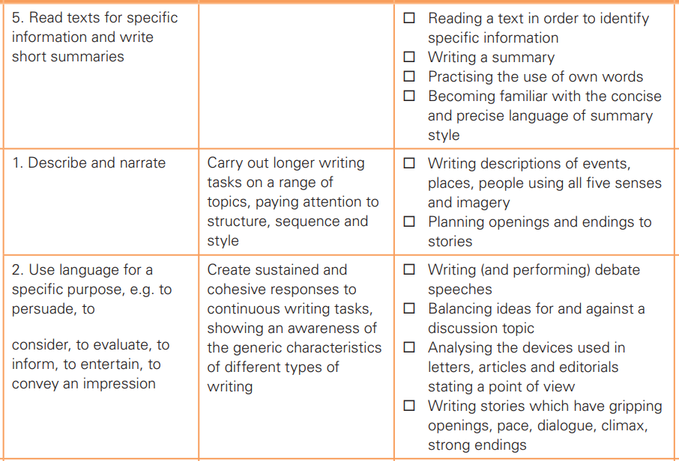
English Literature – 7.5 hours

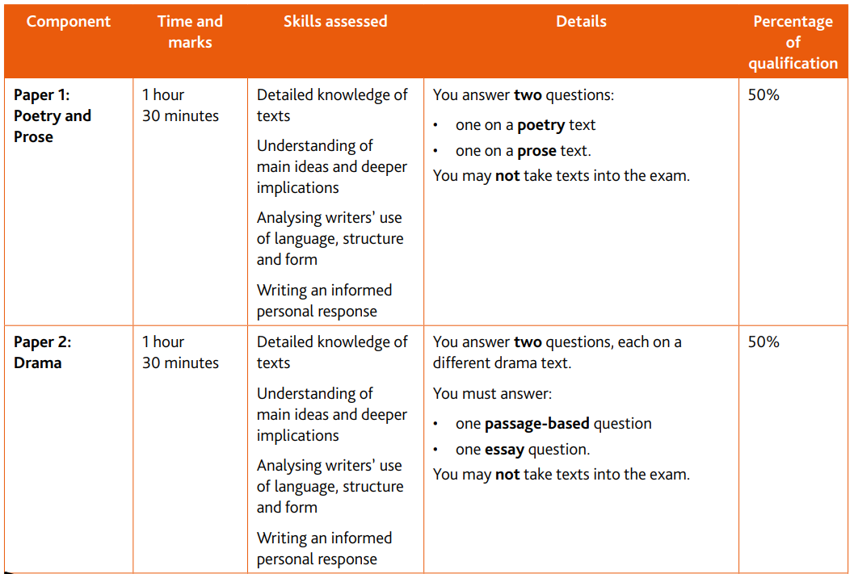

Paper 1 Texts
Section A: Songs of Ourselves Poetry Anthology
Section B: Rebecca
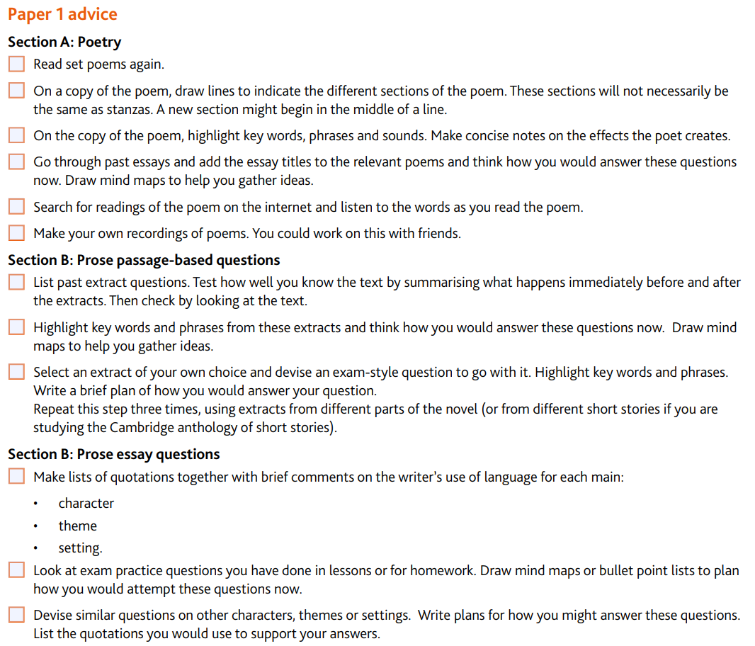
Paper 2 Texts
Othello
Journey’s End

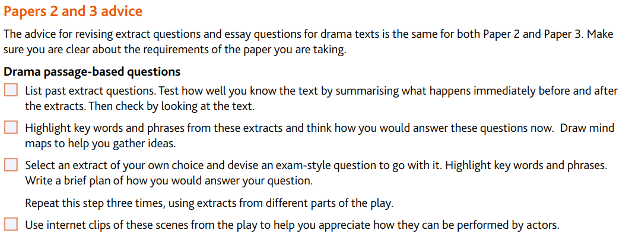
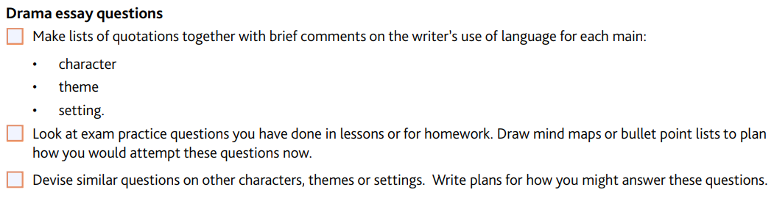

15 hours of Español

ANÁLISIS DEL TEXTO NARRATIVO (PROSA) 5 HOURS
OBRAS:
- Isabel Allende, La ciudad de las bestias
- Historia de una maestra
- BIOGRAFÍA
- CONTEXTOS
- TEMA E IDEAS
- PERSONAJES:
- Caracterización
- Tipos de Pesonajes
https://www.diferenciador.com/tipos-de-personajes/
- Revisión de tablas de personajes
- NARRADOR
Tipos de narradores
- ESPACIO
- TIEMPO
http://lenguajemedia.blogspot.com/2011/05/el-espacio-y-el-tiempo-en-la-narracion.html
http://descargas.pntic.mec.es/recursos_educativos/It_didac/Leng_ESO/2/06/01_El_texto_narrativo/tiempo.html#:~:text=Tiempo%20interno%2C%20narrativo%20o%20del,hasta%20lo%20que%20pasa%20despu%C3%A9s.
- ESTRUCTURA EXTERNA E INTERNA
https://www.laescribeteca.com/post/capitulos-estructura-externa-texto-narrativo
- RECURSOS LITERARIOS Y LINGÜÍSTICOS: lenguaje, tono, tipos de oraciones y tipos de palabras, simbología.

ANÁLISIS DEL TEXTO POÉTICO (LÍRICA) 5 HOURS
POEMARIO: GLORIA FUERTES
- BIOGRAFÍA
- CONTEXTOS
- TEMAS, IDEAS Y SENTIMIENTOS
- ESTRUCTURA EXTERNA E INTERNA
- E. EXTERNA: versos, estrofas, rima, ritmo
- E. INTERNA: tono, conexión título-contenido,
- VOZ POÉTICA: quién y a quién se dirige.
- RECURSOS DE LA FORMA: figuras literarias, tipos de palabras y tipos de oraciones, simbología.

ANÁLISIS DEL TEXTO DRAMÁTICO 5 HOURS
OBRA: Ramón del Valle Inclán, Luces de Bohemia
- BIOGRAFÍA
- CONTEXTOS
- TEMAS, IDEAS Y SENTIMIENTOS
- ESTRUCTURA EXTERNA E INTERNA
- E. Externa: http://www.bajoladiabla.com/texto-dramatico/6-estructura-del-texto-dramatico/#:~:text=Estructura%20externa,cambios%20de%20espacio%20y%20tiempo.
- E. Interna: Inicio, conflicto, clímax, desenlace
- TEMA E IDEAS

- PERSONAJES:
- Caracterización
- Tipos de Personajes
https://www.diferenciador.com/tipos-de-personajes/
- Revisión de tablas de personajes

- ESPACIO
https://www.teatralizarte.com.ar/07-DRAMATURGIA/07-01-ESTRUCTURA/espacioytiempo/espacioytiempo.htm#:~:text=El%20espacio%20refiere%20tanto%20al,al%20comienzo%20de%20la%20obra.

- TIEMPO
http://www.bajoladiabla.com/texto-dramatico/8-el-tiempo-en-el-texto-dramatico/

- RECURSOS DRAMÁTICOS: acotaciones, diálogos
- RECURSOS LITERARIOS Y LINGÜÍSTICOS: lenguaje, tono, tipos de oraciones y tipos de palabras, figuras literarias, simbología.

15 hours of Geography

Use the Learner Guide – in Teams and printed

Needed for the exams:
Paper 1 | Paper 2
Pen - black  Pencil - only for diagrams  Eraser  Sharpener  Spare pen  Highlighter  Calculator  Ruler | Pen - black  Pencil - only for diagrams  Eraser  Sharpener  Spare pen  Highlighter  Calculator  Ruler  Scrap paper – given to you  Protractor  (You can bring a magnifying glass and piece of string if you would like)

BUG the question
B - Box the command word
U - Underline the keywords
G - Go back over the question to make sure you understand, then check the marks available. Write down notes to make sure you don’t forget what to include (also if you run out of time).

Command words:
Describe: Say what you can see (Graph - use data, map - name locations) say it so someone who can’t see it knows what you’re talking about.
Identify: find something
Name: Give the specific place/ feature/ graph.
Calculate: Going to have to do some maths
Explain: Give reasons why (develop points)
Discuss: two+/ both sides of the argument
Sketch: draw a simple diagram

Keywords:
Distribution: How it is spread out
Trends: What is the pattern
Use data: USE THE DATA
Use the graph: USE THE GRAPH
Shown in Fig…: USE THE FIGURE (graph, photo, diagram…)
Only using Fig: ONLY use the figure.
You could use a diagram: USE a diagram LABEL it
Causes: what made the event happen
Effects/ impacts: what happened after the event, because of it
Responses: How did people react to the event
Solutions: How can a problem be solved

7 mark questions:
- Case study - named
- Location description of case study - where is it (direct a person who has a map)
- Data and statistics - numbers
- Named places in the area - towns/ cities, buildings
- Answer what the question is asking

PEA
P - Point - answer the question.
E - Evidence - use data to support your point
A - Analysis - how does the evidence support your point, explain
You can bullet point these answers, but writing in full is likely to get you more marks.

Theme 1: Population and Settlement – 4 hours
1.1 Population Dynamics
1.2 Migration
1.3 Population Structure
1.4 Population density and distribution
1.5 Settlement and service provision
1.6 Urban settlements
1.7 Urbanisation

Theme 2: The Natural Environment – 4 hours
2.1 Earthquakes and volcanoes
2.2 Rivers
2.3 Coasts
2.4 Weather
2.5 Climate and natural vegetation

Theme 3: Economic Development – 4 hours
3.1 Development
3.2 Food Production
3.3 Industry
3.4 Tourism
3.5 Energy
3.6 Water
3.7 Economic Risks of Economic Development

Paper 2: Skills – 3 hours
Map skills
Graph skills
Maths skills
Interpreting photographs

15 hours of History

Paper 1:
KQ1 – Were the peace treaties of 1919-23 fair? - 3 hours
- What were the motives and aims of the big three at Versailles?
- Did all the victors of WW1 get what they wanted and why?
- What was the impact of the Treaty of Versailles on Germany up to 1923?
- Could the peace treaties of 1919-23 be justified at the time?

KQ2 – To what extent was the League of Nations a success? - 3 hours
- How successful was the League in the 1920s?
- How far did the weaknesses in the Leagues organisation make its failure inevitable?
- How fad did the depression make the work of the League more difficult?
- How successful was the League in the 1930s?

KQ4 – Who was to blame for the Cold War? - 3 hours
- Why did the USSR and USA alliance begin to break down in 1945?
- How had the USSR gained control of easter Europe by 1948?
- How did the USA react to Soviet expansionism?
- What were the consequences of the Belin Blockade?
- Who was more to blame for starting the Cold War: USA or the USSR?

KQ5 – How effectively did the USA contain the spread of communism? - 3 hours
- The Korean War, 1950-53 (Causes, events, consequences)
- The Cuban Missile Crisis of 1962 (causes, events, consequences)
- US involvement in the Vietnam War

KQ3 – Why had international peace collapsed by 1939? - 1 hour
- What were the long-term consequences of the treaties of 1919-23?
- What were the consequences of the failures of the League of Nations?
- How far was Hitler’s foreign policy to blame for the outbreak of war in 1939?
- Was the policy of appeasement justified?
- How important was the Nazi-Soviet Pact?
- Why did Britain and France declare war on Germany in 1939?

Paper 2 skills – 2 hours

15 hours of Biology

Please note that you can choose to do these in any order and the timings are guidelines based on the recommended teaching hours. Adjust this based on your strengths and weaknesses.
Notes:
- All key definitions are in the files section in TEAMs, as well as a link to the website in the sites along the top where you can test yourself using Quizlet.
- Past paper questions and mark schemes will be uploaded into the folder on TEAMs. Attempt the questions independently first then refer to the mark schemes to fill in any gaps.

- Characteristics of Living Organisms (0.25hr)
- Organisation of the Organism (0.25hr)
- Movement into and out of Cells (1hr)
- Biological Molecules (1hr)
- Enzymes (0.5hr)
- Plant Nutrition (0.5hr)
- Human Nutrition (1hr)
- Transport in Plants (0.5hr)
- Transport in Animals (1hr)
- Diseases and Immunity (1hr)
- Gas Exchange in Humans (0.5hr)
- Respiration (0.25hr)
- Excretion in Humans (1hr)
- Coordination and Response (1hr)
- Drugs (0.25hr)
- Reproduction (1hr)
- Inheritance (1hr)
- Variation and Selection (1hr)
- Organisms and the Environment (0.5hr)
- Human Influences on the Ecosystem (1hr)
- Biotechnology and Genetic Modification (1hr)

15 hours of Chemistry

Students should review the following topics:
Please note that you can choose to do these in any order and the timings are guidelines based on the recommended teaching hours. Adjust this based on your strengths and weaknesses.
1 States of matter (1h)
1.1 Solids, liquids and gases
1.2 Diffusion
2 Atoms, elements and compounds (1h)
2.1 Elements, compounds and mixtures
2.2 Atomic structure and the Periodic Table
2.3 Isotopes
2.4 Ions and ionic bonds
2.5 Simple molecules and covalent bonds
2.6 Giant covalent structures
2.7 Metallic bonding
3 Stoichiometry (2h)
3.1 Formulae
3.2 Relative masses of atoms and molecules
3.3 The mole and the Avogadro constant
4 Electrochemistry (2h)
4.1 Electrolysis
4.2 Hydrogen–oxygen fuel cells
5 Chemical energetic (1h)
5.1 Exothermic and endothermic reactions
6 Chemical reactions (1h)
6.1 Physical and chemical changes
6.2 Rate of reaction
6.3 Reversible reactions and equilibrium
6.4 Redox
7 Acids, bases and salts (1h)
7.1 The characteristic properties of acids and bases
7.2 Oxides
7.3 Preparation of salts
8 The Periodic Table (1h)
8.1 Arrangement of elements
8.2 Group I properties
8.3 Group VII properties
8.4 Transition elements
8.5 Noble gases
9 Metals (1h)
9.1 Properties of metals
9.2 Uses of metals
9.3 Alloys and their properties
9.4 Reactivity series
9.5 Corrosion of metals
9.6 Extraction of metals
10 Chemistry of the environment (1h)
10.1 Water
10.2 Fertilisers
10.3 Air quality and climate
11 Organic chemistry (2h)
11.1 Formulae, functional groups and terminology
11.2 Naming organic compounds
11.3 Fuels
11.4 Alkanes
11.5 Alkenes
11.6 Alcohols
11.7 Carboxylic acids
11.8 Polymers
12 Experimental techniques and chemical analysis (1h)
12.1 Experimental design
12.2 Acid–base titrations
12.3 Chromatography
12.4 Separation and purification
12.5 Identification of ions and gases

15 hours of Physics

The best way to revise for physics is by making past papers, this way you learn the questions language, the answers they want and what they want you to do.

Paper 2 practice 3 hours; Paper 4 practice 3 hours; Paper 6 practice 3 hours

Do 1 or 2 past papers, finish these past papers, then see the mark scheme to see the answers and what the IGCSE was expecting. Take a close look at what they gave a mark for and what they didn’t give a mark.

1 General physics - 1 hour
- Measurements
- Motion
- Forces
- Turning effects of forces
- Matter
- Energy transformation
- Energy resources
- Work and power

2 Thermal physics - 1 hour
- Kinetic model of matter
- Thermal properties of matter
- Thermal energy transfers

3 Physics of waves - 1 hour
- Sound
- Light
- Properties of waves
- Spectra

4 Electricity and magnetism - 1 hour
- Magnetism
- Static electricity
- Electrical quantities
- Electric cicuits
- Electromagnetic forces
- Electromagnetic induction

5 Atomic physics 1 - hour
- Nuclear atom
- Radioactivity

6 Space physics 1 - hour
- Planetary system
- Creation of planets
- Star cycles
15 hours of Maths

Dear year 11 students, you can find all the lessons, the syllabus, the topic and the IGCSE Maths, both Extended and Core, in Microsoft Teams.
According to the Cambridge Syllabus, Extended examinations have the following percentages.
Find your times of revision in proportion to them:

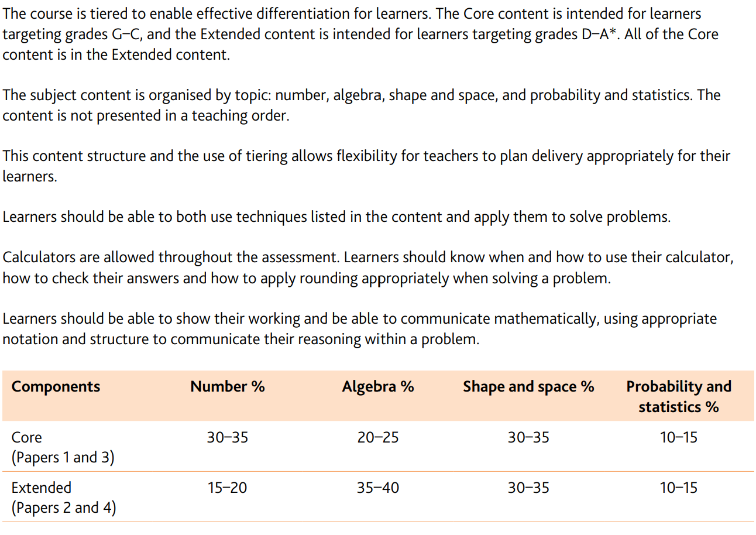

We will continue solving past paper in the lessons and we can use the following guide and formulas to revise.

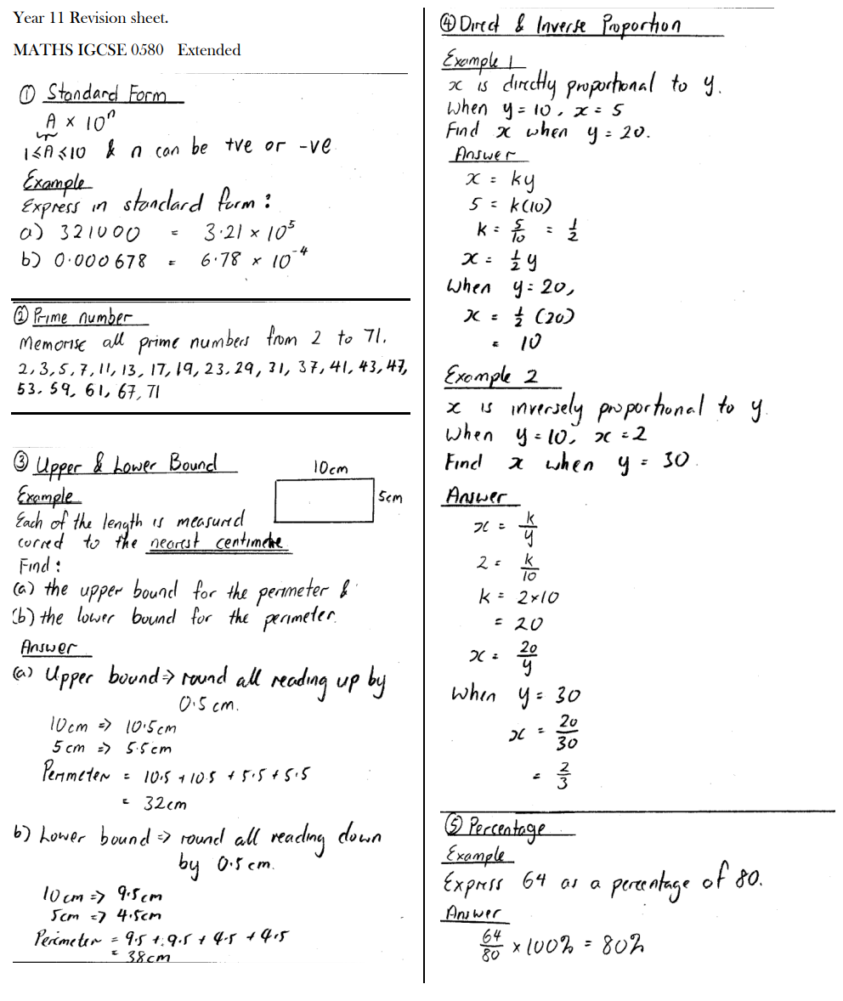
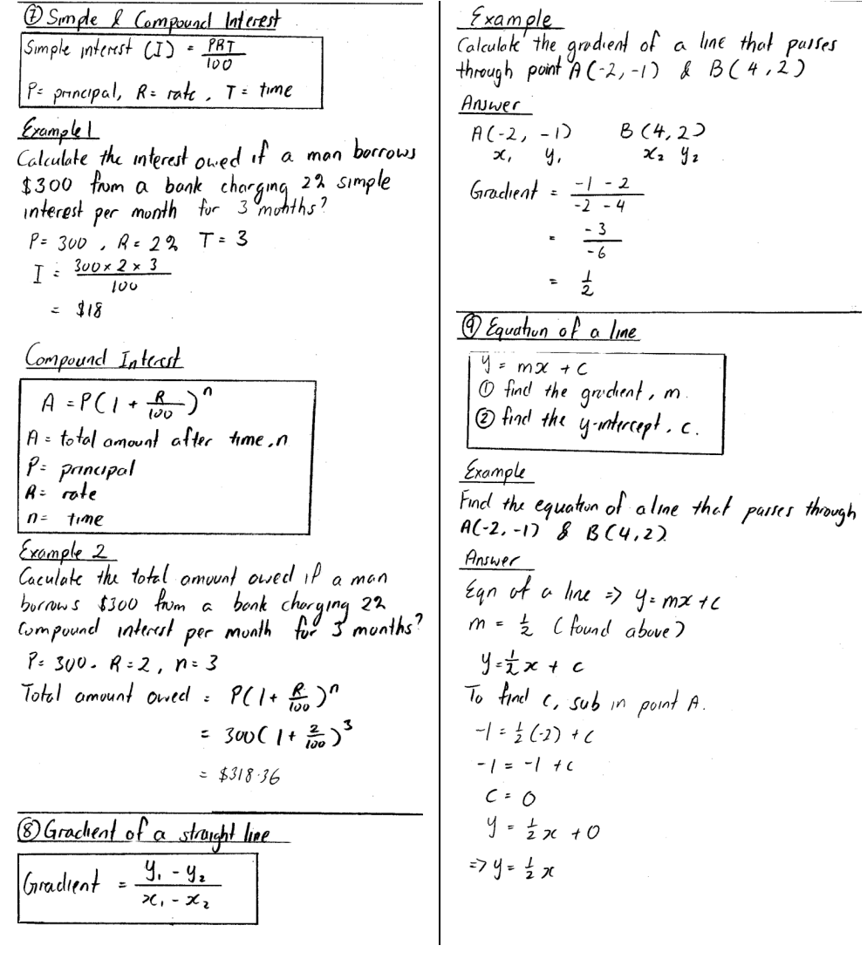
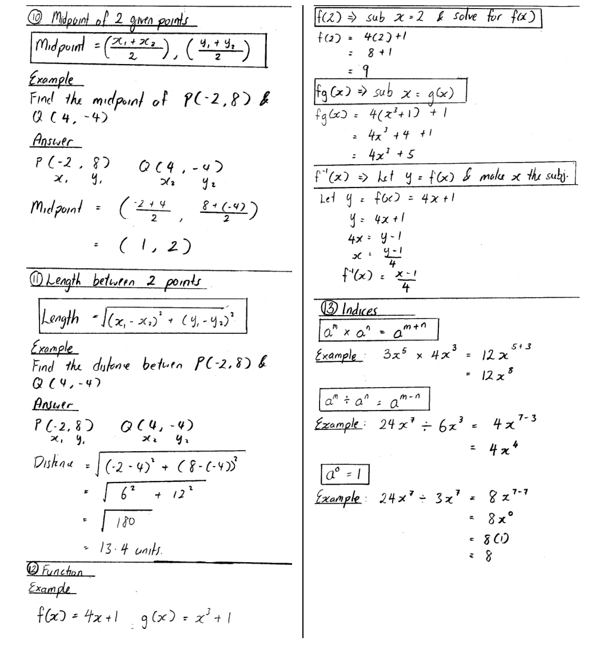
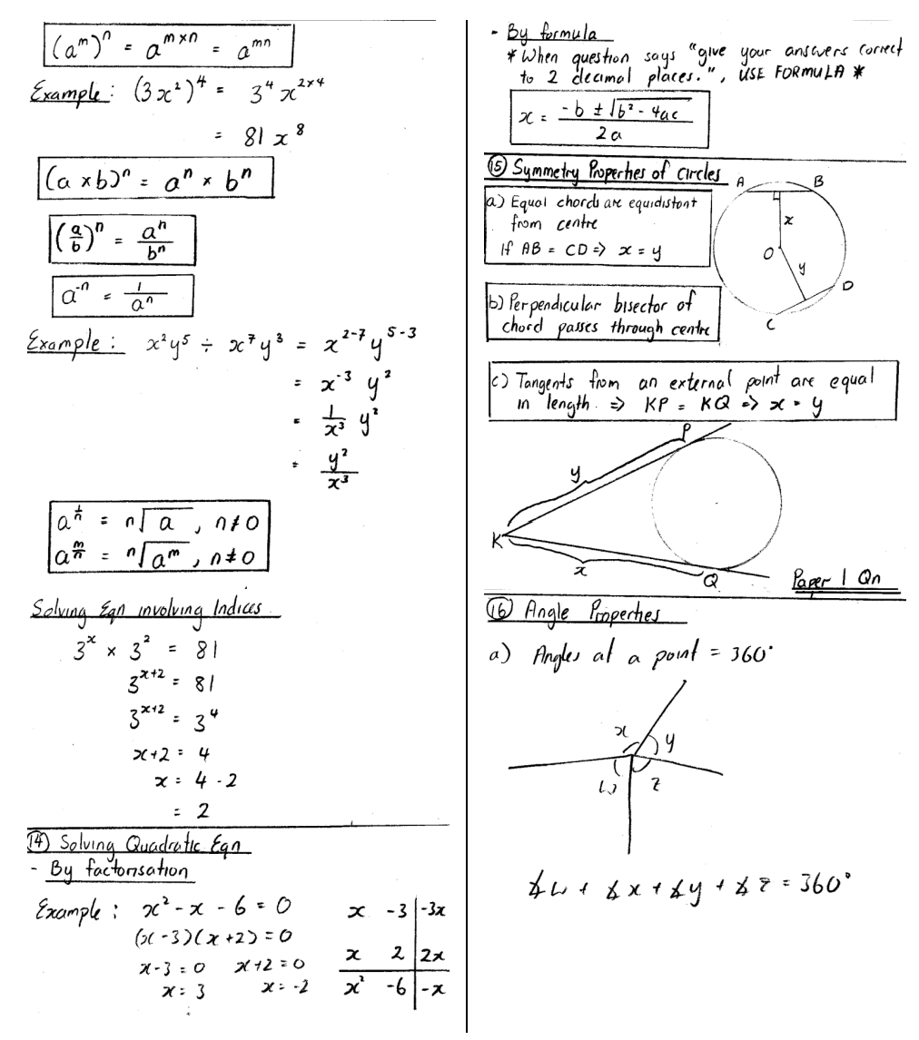
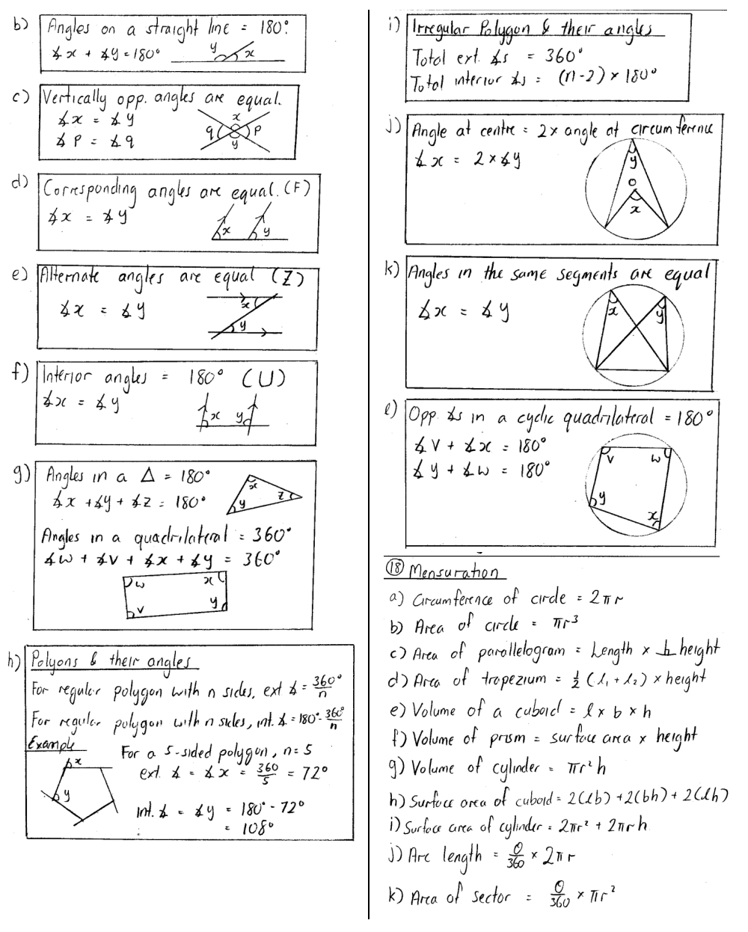
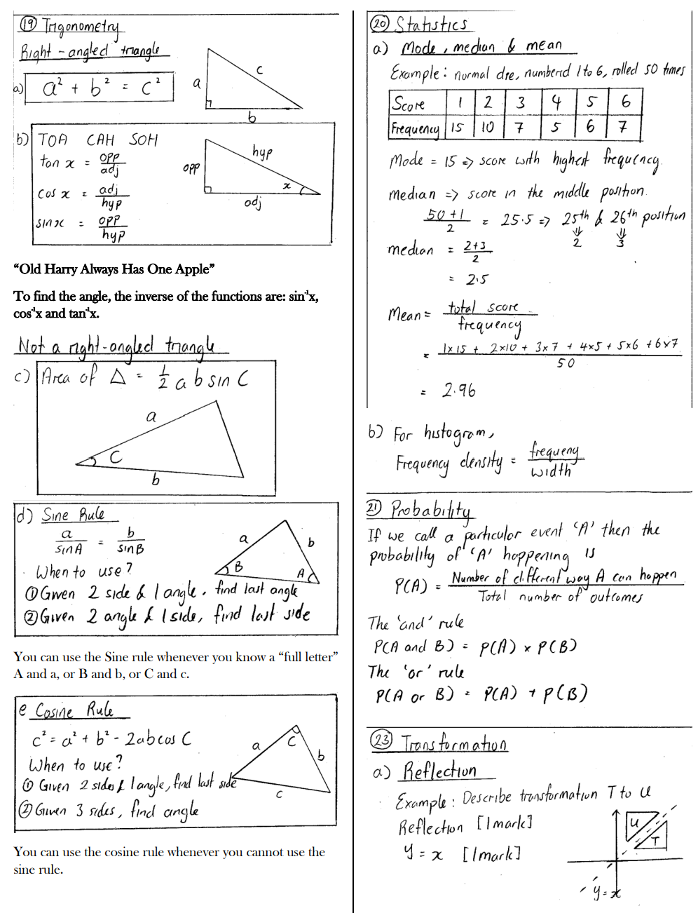

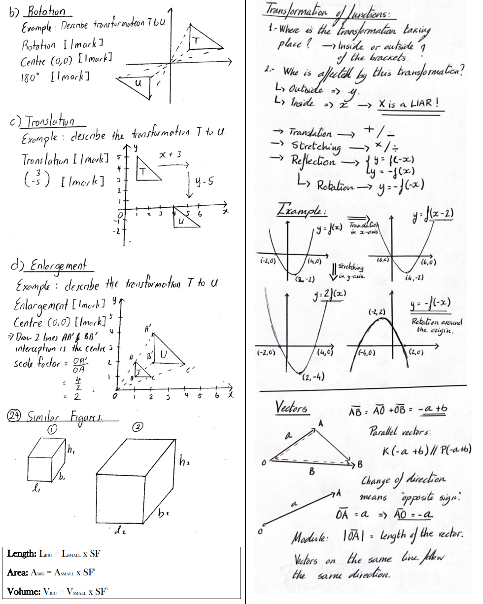
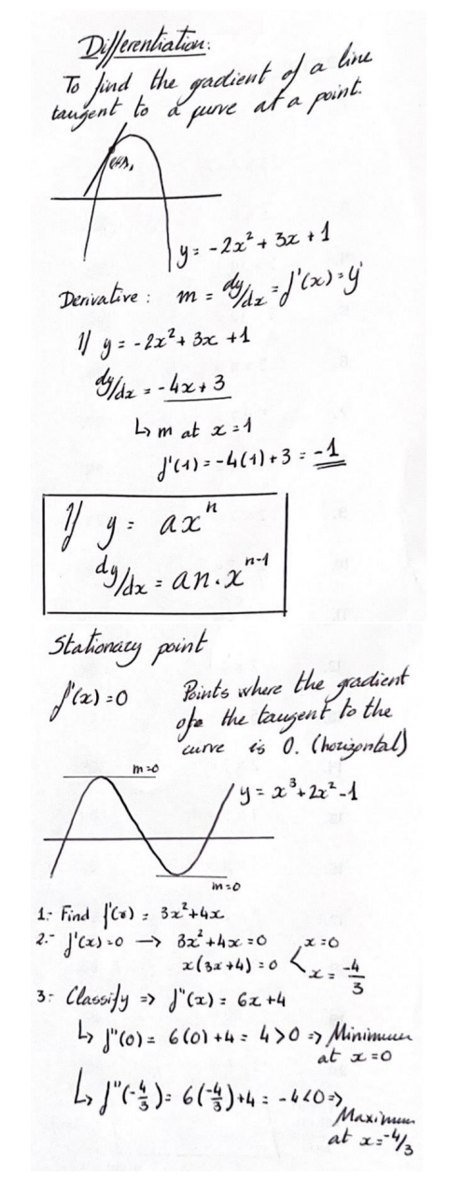

15 hours of Visual Arts

Component 2: Examination- 50%
The second component is an externally set assignment and is marked by Cambridge International. Students will receive a question paper from Cambridge Intl., which they will choose one prompt question from. This will be their theme for Component 2.
There are two parts to this component:
· The supporting studies, which students will create during the approximate 4 months preparation period after receipt of the question paper and before the supervised test (final outcome).
· A final outcome, produced during a supervised test of 8 hours’ total duration.
Students are allowed to bring in their supporting study sheets and to work in any media during the 8 hour examination.
Component 2 consists of 5 - A2 sheets in total.
- 1 x final artwork – a two or three-dimensional artwork, maximum weight 4.5kgs and maximum dimension in any direction of 750mm, completed within the 8 hour Art Exam. Painting and Related Media students are encouraged to submit a final work that is a maximum size of A2 (larger works must be photographed, prior to sending away for assessment).
- A maximum of 2 x A2 sheets (4 sides) of preparatory work. This is a body of work illustrating a visual response to one examination question, using any appropriate colours, tones, mediums, processes or techniques. The preparatory work is completed in the eight weeks before the examination and must include direct observation from primary sources, research, analysis and development of ideas.

Component 2 – Externally Set Assignment
This is an externally set assignment which is marked by Cambridge International. There is a question paper for this component. You may download the question paper from Cambridge International and give it to candidates as soon as it is released. Refer to the Cambridge Handbook for the year of examination for more information.
There are two parts to this component:
- supporting studies created during the preparation period and
- a final outcome, produced during a supervised test of 8 hours’ total duration.
- Candidates can choose to work in any of the areas of study and should explore one starting point set by Cambridge International. Candidates produce their supporting studies during the preparation period, after receipt of the paper and before the supervised test.
- Candidates explore and develop supporting studies in response to the starting point, producing work leading to a final outcome that is produced during the supervised test.
- Candidates may, but do not have to, explore the same area of study for Component 1.
- The supporting studies must be taken into the supervised test in order to inform the final outcome. They should show how the candidates have worked through artistic processes towards the assessment objectives. The final outcome should show the results of this process.
- Candidates should select supporting studies that show how they have:
- recorded ideas and observations from first-hand studies, such as their own drawings and photography, and secondary imagery from books, magazines and the internet
- explored and experimented with different media, techniques and processes
- carried out relevant research into artists, designers and cultural influences related to their ideas
- selected, reviewed and refined their ideas as work progresses to plan and produce a personal and coherent final outcome.
- The supporting studies can be up to two sheets of A2. Candidates may use both sides of the paper. They may work in any size or appropriate media. Any work that is fragile, three-dimensional or larger than A2 must be photographed. The photographs must be mounted on A2 and clearly labelled. This applies to both the supporting studies and the final outcome.

Back to contents page www.cambridgeinternational.org/igcse ₁₇
Cambridge IGCSE Art & Design 0400 syllabus for 2024. Details of the assessment
Component 2 is marked against the assessment criteria at the end of this section. Cambridge International will assess both the supporting studies and the final outcome together and award a single mark out of 100. Work for this component must not be sent with Component 1.
Avoidance of plagiarism
Candidates must be taught the meaning and significance of plagiarism. Candidates should provide references for all source materials used in their research.
The candidate is required to sign a declaration stating that the Coursework is their own work and you must countersign to confirm that you believe the work is that of the candidate. The declaration of authenticity
form, and the instructions for completing the form, should be downloaded from the samples database at www.cambridgeinternational.org/samples. The database will ask you for the syllabus code (i.e. 0400) and your centre number, after which it will take you to the correct forms. Follow the instructions on the form. Further details can be found in the Cambridge Handbook.
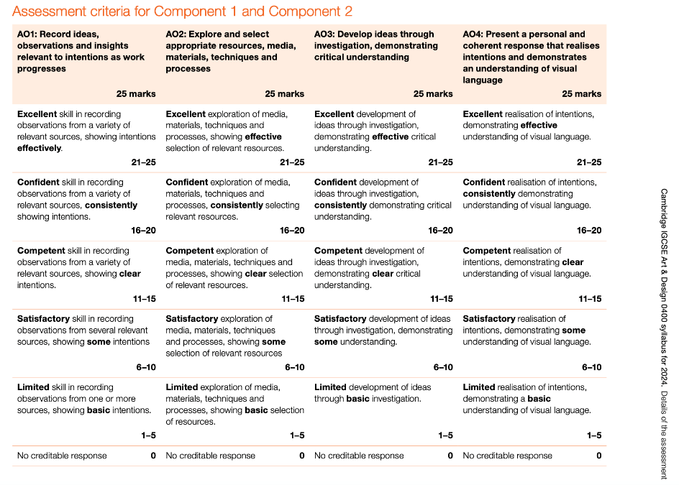

15 hours of Music

RELEVANT AND HELPFUL DOCUMENTS ARE AVAILABLE IN TEAMS.

COMPONENT 1 – LISTENING (5 HOURS)
Written paper, c.1 hour 15 minutes, 70 marks
This component is based on audio material supplied by Cambridge International. It is assumed that centres will have an audio player of reasonable quality, capable of reproducing the bass clearly.
The extracts or pieces played will be from a wide range of styles and traditions. The questions test understanding and perception of the music. Candidates are expected to follow any complete or skeleton scores or diagrams provided. All questions in Sections A, B and C are compulsory and will either require short answers or will be in a multiple‑choice format.
Extracts in Sections A, B and C will be played four times; extracts in Section D will be played twice.
In Sections A, B and C, candidates may be asked questions relating to rudiments, melody and rhythm, harmony (including recognition of chords, keys and cadences), ensembles, instruments and instrumental effects, structure, compositional devices, texture, style or genre, as appropriate to the music.
The main focus of each section is as follows:

Section A: Unprepared Western Repertoire [16 marks]
Extracts from two works which may be instrumental and/or vocal selected from the Baroque, Classical and Romantic periods and the Twentieth Century. In addition to questions on the areas listed above, candidates may also be required to identify the period and/or suggest a possible composer.

Section B: World Music [22 marks]
Extracts from three pieces of music. Two of the pieces (6 marks each) will be selected from African and Arab, Latin American, Chinese, Japanese, Indian and Indonesian traditions.
In addition to questions on the areas listed above, candidates will also be required to identify the possible continent/country or origin.
The third piece (10 marks) will be taken from the World Focus prescribed each year from the non‑Western music traditions.

World Focus for examination in 2023 – Indian Music
In the examination, candidates will be tested on a range of knowledge and understanding of the prescribed World Focus. Although the precise nature of questions will depend on the individual characteristics of the country or area, candidates should be prepared to answer questions under the following main headings:
- instruments and effects
- melody and rhythm
- texture
- structure
- general background information about the context of each country or area.
Candidates will not be assessed on spelling, providing the meaning of their answers is clear.
Further information on the World Focus topic is available in the Teachers’ Guide to Set Works and the World Focus (Available in Teams). It is essential that centres download this document from www.cambridgeinternational.org, as it contains details of the vocabulary, specific instruments and other contextual information that candidates may be asked about in the examination.

Section C: Skeleton Score [16 marks]
A single extract with skeleton score. In addition to questions on the areas listed above, candidates will be expected to undertake simple rhythmic and/or melodic dictation. They may also be required to identify the period of the music and/or to suggest the name of a likely composer.

Section D: Set Work [16 marks]
Candidates are expected to have prepared one Set Work.
For their chosen work, candidates will hear two extracts (played twice). A skeleton score of the extracts will be provided in the question paper. Candidates will be expected to answer questions on any aspect of the music in the extract (whether or not it is shown in the skeleton score); there may also be questions on the music which comes before or after the extract itself.
Set Works for examination in 2023:
EITHER
Haydn: Symphony No. 100, Hob. I/100 Military: Movements 3 and 4
OR
Brahms: Academic Festival Overture

General observations
It is most important that candidates are able to hear their Set Work as often as possible, so that they become thoroughly familiar with the music primarily through listening. Recordings should therefore always be available to them in school. Wherever possible, it is also desirable for candidates to have their own copy of a recording, so that they can listen at home as well. With this in mind, every effort has been made to ensure that all the Set Works are available digitally or on good quality but inexpensive CD recordings (e.g. those issued on the Naxos label). The importance of experiencing the sound of the music at first hand cannot be stressed too much.
In the examination, candidates will be tested on a range of knowledge and understanding of their chosen work. Although the precise nature of questions will depend upon the individual characteristics of the work concerned, candidates should be prepared to answer questions under the following main headings:
- structure and terminology
- themes and their transformations
- key centres and modulations
- identification of chords
- instruments
- transposition
- score markings, performance directions, instrumental effects
- general background information about the context and genre of each work.

COMPONENT 2 – PERFORMING (5 HOURS)
Internally marked/externally moderated coursework, 50 marks
Component 2 consists of prepared performances of the candidate’s own choice, all of which must be recorded.
Candidates must:
(i) sing or play individually – either one piece or two short contrasting pieces (which should be on the same instrument)

and
(ii) sing or play in an ensemble – either one piece or two short contrasting pieces (which should be on the same instrument – but this does not need to be the same instrument as that offered for individual performing).
The total playing time should be between 4 and 10 minutes.
The music performed should be appropriate, in its technical and musical demands, to the candidate’s stage of development at the time of the examination. Positive credit is given for the following:
- the range of technical and musical skills demonstrated
- accuracy of playing the notes and rhythm (in notated music) OR quality of improvisation (in music that is not notated)
- choice and control of tempo (in an individual performance) OR ensemble coordination (in an ensemble performance)
- sensitivity to phrasing and expression (e) technical control of the instrument.
An individual performance may be either unaccompanied or accompanied (but the accompaniment should be played if the composer wrote one and a suitable accompanist is available). Any accompaniment may be live or through a backing track. Singers who choose to accompany themselves (e.g. on the guitar) should be assessed for their singing only.
An ensemble should consist of two or more live performers, and the candidate’s part may not be consistently doubled by any other performer. Pianists may offer accompaniment; duos are allowed provided the candidate’s part demonstrates genuine ensemble skills and could not also be counted as a solo. Candidates should ensure that they do not offer as an ensemble any piece that could be presented as their individual performance, e.g. a flautist playing with piano accompaniment would count as an individual performance for the flautist. The other musicians in an ensemble do not also have to be candidates for the examination. Backing tracks and/or multi‑tracking must not be used in any part of the ensemble performance.

COMPONENT 3 – COMPOSING (5 HOURS)
Internally marked and externally moderated coursework, 50 marks
Candidates submit two compositions, written for different instruments and/or voices, which must be recorded.
Composition 1 must be written in a Western, tonal style and must demonstrate familiarity with the basic principles of traditional harmonic language; this composition must be fully notated using staff notation and the score must be submitted with the recording.
Composition 2 may be in any style of the candidate’s choice and may be notated in whatever form of notation is appropriate to the music. If staff notation is not used, the intentions of the notation must be clearly explained in an accompanying commentary. The score and commentary (if applicable) must be submitted with the recording.
Notation may be either handwritten or computer generated, but all scores must be accurately edited. If notations other than staff notation are submitted, they must be accurately designed to show the duration of the sounds represented by whatever symbols are used (e.g. guitar chord symbols on their own do not show duration). Alternative notation should not be used for any piece which is capable of being notated in staff notation.
Teachers must certify that the compositions are the individual work of the candidate who claims authorship.
Candidates will be given positive credit for:
- their ideas
- the structure of their compositions
- their use of the chosen medium (d) compositional technique (e) score presentation/notation.

15 hours of IGCSE Physical Education

- All presentations for each of the 4 units are on the Microsoft Teams page for IGCSE PE
- Also visit GCSE Bitesize HERE (Web site revision tasks and information)
- CIE IGCSE PE Revision resources HERE
- Past papers and mark schemes HERE (practice questions and answers)
- Specification HERE (pages 10 – 20 for theory)

Headlines for revision:

Anatomy and Physiology (Unit 1) – 3.5 hours

- Skeletal and muscular system
- Respiratory system
- Circulatory system
- Energy supply and effects of exercise on the body
- Simple Biomechanics

Health, Fitness and Training (Unit 2) – 3.5 hours

- Health and wellbeing
- The relationship between health and fitness
- Diet and energy systems
- Components of fitness
- Test protocols
- Reasons for fitness testing
- VO2 Max (maximum oxygen uptake)
- Principles of training
- Methods of training

Skill acquisition and psychology (Unit 3) – 3.5 hours

- Skill and ability
- Skilled performance
- Skill classification
- Simple information processing model
- The stages of learning
- Feedback
- Guidance
- Goal setting
- Motivation
- Arousal
- Anxiety and relaxation
- Personality

Social, cultural and ethical influences (Unit 4) – 3.5 hours

- Leisure and recreation
- Growth in leisure activities
- The sports development pyramid
- Sponsorship
- Media
- Global events
- Professional and amateur performers
- Technology
- Access and participation
- Performance enhancing drugs
- Sportsmanship and gamesmanship
- Managing risk in sport (We will cover his in revision after the practical has finished)
- Injuries (We will cover this in revision after the practical has finished)

Good luck and work hard! You will get what you deserve!!!!

