SERVICE ACTIONS NEWS BULLETIN No.1

As schools and businesses close, many who have never needed help now need assistance, and the seniors, children and families who rely on our community need us more than ever.
¿How can we help our community during Covid -19 without leaving our home?
Well there are many initiatives running, organized by the city mayor, government institutions, foundations and private companies.

Here you will find a list of options:

Option 1: By clicking in https://www.darunamanoecuador.com/, you can help stock the shelves of families in need with food and hygiene items. You can choose kits from $5 up to $ 20 dollars.
- There is also a kit for nurses and doctors that includes 6 masks and gloves.

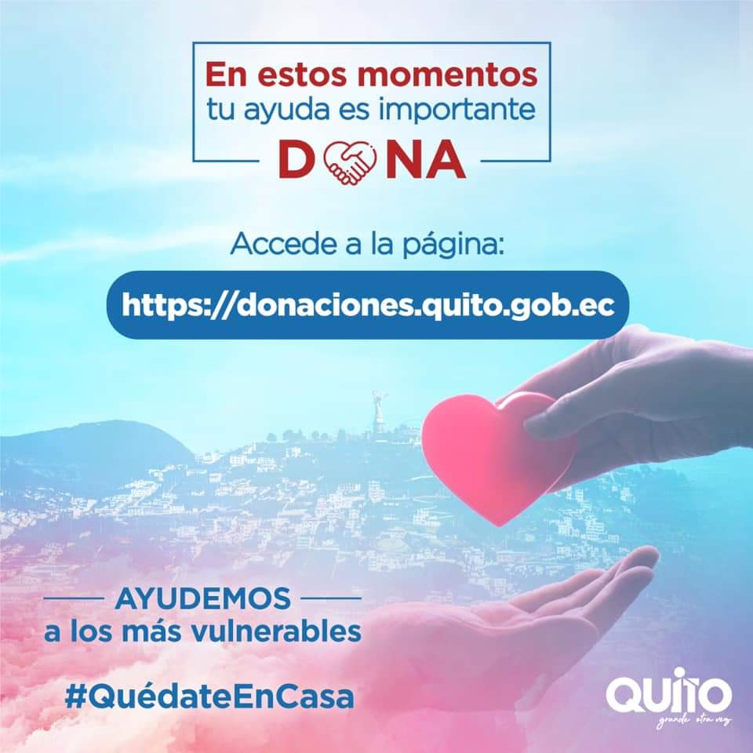

Option 2: You can host a virtual food drive to fundraise with your family, with your building, conjunto or urbanizacion and send them to the local shelter in Casa de la Cultura. When you have the kits ready, please write an email to these email addresses: secretariadeinclusion@quito.gob.ec or patronatosanjose@quito.gob.ec and they will collect it from your place.
Or click in https://donaciones.quito.gob.ec.

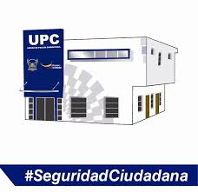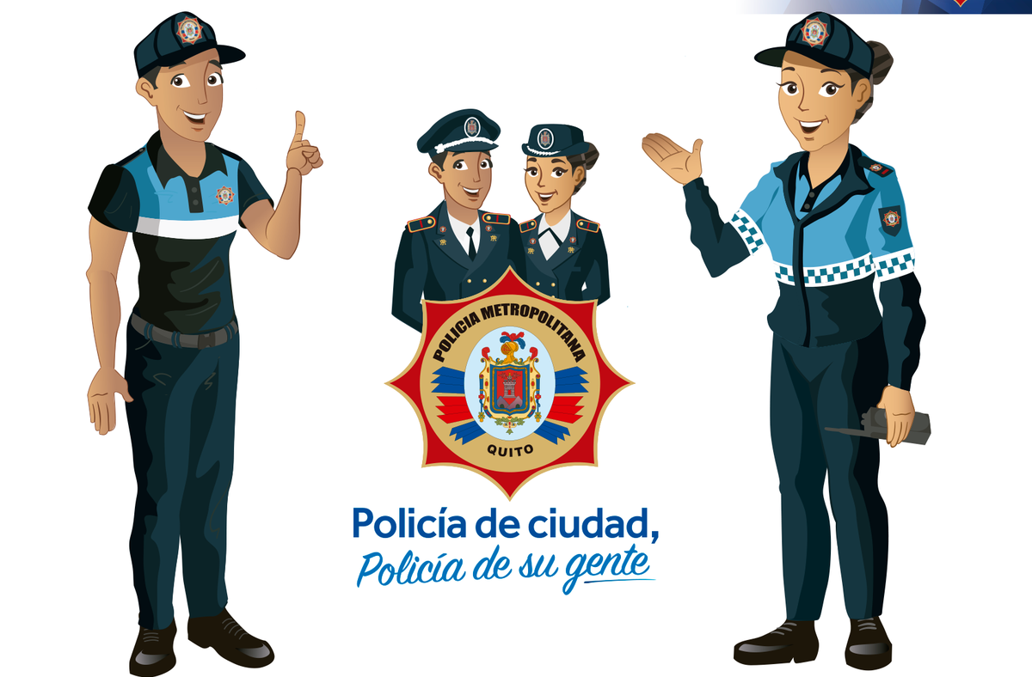

Option 3: Donate alcohol, sanitizers or wipes to your local police station and firefighters. They really need them. Here you have the telephone numbers and addresses, check the one close to your neighborhood http://www.communitywalk.com/map/list/458390.

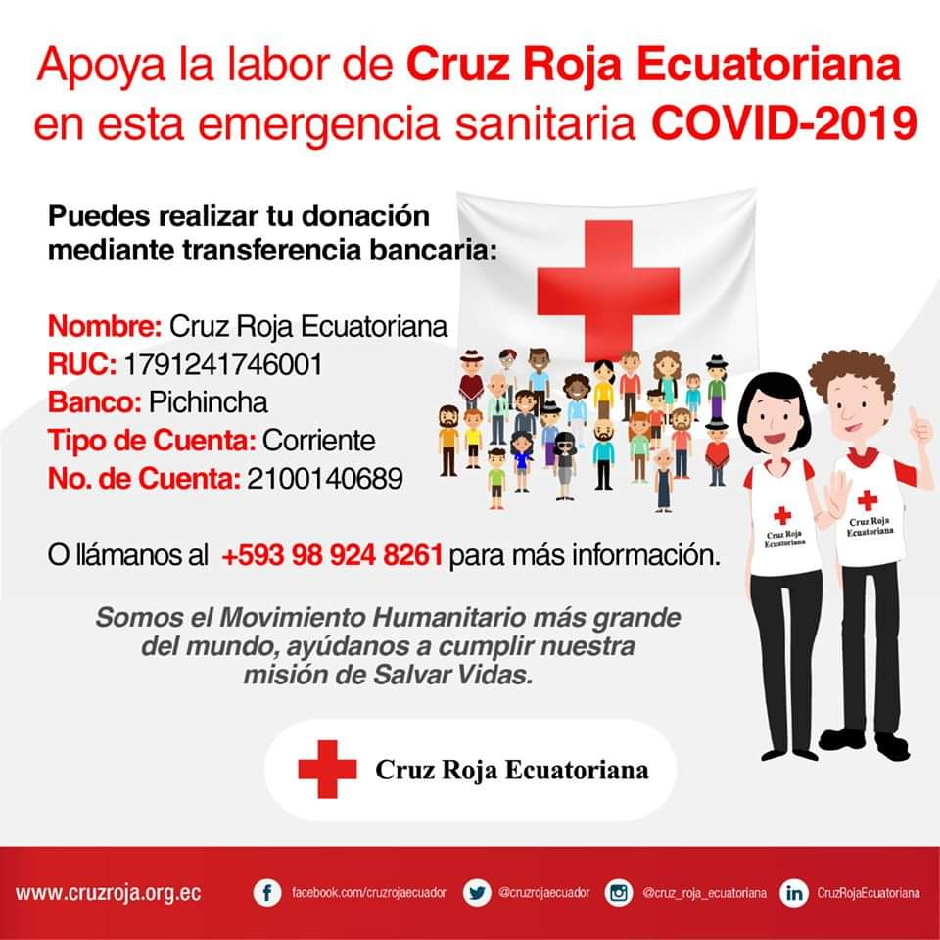

Option 4: Donate money or medical supplies to the Red Cross.

Don't forget that helping others and encouraging others in difficult times are often acts of kindness that have more meaning that you may realize!

As information changes we will keep you informed with more ways to contribute to our community or if you know some other ways, please contact me pmontenegro@britishschoolquito.edu.ec.

CAS AND COMMUNITY PROJECTS
BSQ -2020

